Smart Vehicle Simulation System using OOP in Java

Name: Nikilesh Prakash V
Reg No: 411625149029
Department: B.E CSE(Cyber Security)
Subject: Object-Oriented Programming
Aim
To design and implement a Smart Vehicle Simulation System using Java that models real-world vehicle behavior such as fuel consumption, driving, and engine control using Object-Oriented Programming concepts.

Objective
- To simulate different vehicle types with unique behaviors
- To demonstrate real-world use of OOP concepts
- To improve modular and reusable code design
- To implement dynamic behavior like fuel usage and refueling
Procedure
Step 1: Create Abstract Vehicle Class
- Defined common attributes: brand, model, fuelType, speed
- Declared abstract methods: start() and stop()
- Implemented methods: drive(), refuel(), displayInfo()
Step 2: Create Car Class
- Inherits from Vehicle
- Uses Diesel engine
- Higher speed and fuel capacity
- Overrides start/stop methods
Step 3: Create Bike Class
- Inherits from Vehicle
- Uses Petrol engine
- Lightweight with lower fuel usage
- Overrides start/stop methods
Step 4: Implement Main Class
- Created objects using polymorphism
- Simulated operations for each vehicle
Step 5: Testing
- Checked fuel reduction while driving
- Verified refueling updates
- Ensured correct method overriding

Code:
abstract class Vehicle {
private String brand;
private String model;
private String fuelType;
private int maxSpeed;
protected int fuelLevel;

Vehicle(String brand, String model, String fuelType, int maxSpeed) {
this.brand = brand;
this.model = model;
this.fuelType = fuelType;
this.maxSpeed = maxSpeed;
this.fuelLevel = 50;
}

abstract void start();
abstract void stop();

void drive() {
if (fuelLevel > 0) {
fuelLevel -= 10;
System.out.println(brand + " is moving... Fuel left: " + fuelLevel);
} else {
System.out.println("Out of fuel!");
}
}

void refuel(int amount) {
fuelLevel += amount;
System.out.println("Refueled: " + amount + " | Total Fuel: " + fuelLevel);
}

void displayInfo() {
System.out.println("\nVehicle: " + brand + " " + model);
System.out.println("Fuel: " + fuelType);
System.out.println("Max Speed: " + maxSpeed + " km/h");
}
}

class Car extends Vehicle {

Car() {
super("Honda", "City", "Diesel", 180);
}

void start() {
System.out.println("Car engine starts with button ignition.");
}

void stop() {
System.out.println("Car engine stops.");
}
}

class Bike extends Vehicle {

Bike() {
super("KTM", "Duke 200", "Petrol", 140);
}

void start() {
System.out.println("Bike starts with self-start.");
}

void stop() {
System.out.println("Bike engine stops.");
}
}

public class Main {
public static void main(String[] args) {

Vehicle car = new Car();
Vehicle bike = new Bike();

// Car simulation
car.start();
car.displayInfo();
car.drive();
car.refuel(20);
car.stop();

// Bike simulation
bike.start();
bike.displayInfo();
bike.drive();
bike.refuel(10);
bike.stop();
}
}

Sample Output
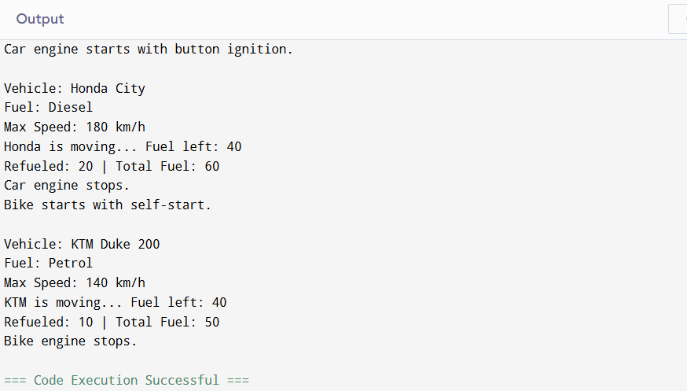
Result:
The Smart Vehicle Simulation System was successfully developed using Java.
The project clearly demonstrates OOP concepts like abstraction, inheritance, encapsulation, and polymorphism.
It provides a realistic simulation of vehicle behavior such as fuel consumption and engine control.

